Michael Modano

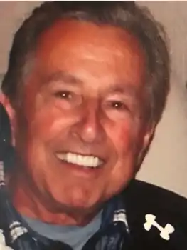

Obituary
Michael Francis Modano, a resident of Westland, Michigan, was gathered into the arms of his Savior Jesus Christ on July 15, 2023, after a season of declining health. He was 87. Michael was born in Boston, Massachusetts on May 28, 1936, son of Michael A. and Eileen Russell Modano. He graduated from Hyde Park High.
Michael was the beloved husband of Karen and the loving father of Linda (Rick) McMorrow, Sandra Withey, and Michael (Allison). He was a fun-loving grandfather and thoroughly enjoyed his nine grandchildren and six great-grandchildren. His many nieces and nephews have fond memories of Uncle Mike. Michael was a devoted and dearly loved brother of the late David Richards, the late Johnny Richards, Paul Modano, Edward Modano (Renee), Elsa Murphy, Audrey Boyle, Carolyn Beller, and the late James Modano. He proudly served his country in the United States Marine Corps from 1954-1962.
Michael was known for his infectious smile and unique sense of humor. He worked for many years as a builder of fine residential homes in the Detroit area. Outside of work Mike and Karen shared the excitement of nurturing and following the professional hockey career of their son Mike. Michael was also passionate about his golf game and enjoyed golfing with his children and grandchildren. He met cherished golfing buddies along the way and was a faithful and delightful friend and neighbor. He will be dearly missed by all those who had the privilege of knowing him.

